DEPARTMENT OF LAND REFORM & RURAL DEVELOPMENT
Security System
Internal Unit Testing Document

Module: Chief Investigator User Type
Tester: Isabella David
DATE: 4 August 2026
Environment: Development / Test
Version: 1.0

Field | Details
Module | SECURITY
User Role | Chief Investigator
Total Test Cases | 7
Passed | 4
Failed | 3
Date Tested | 4 August 2026

TEST CASES
Test Case CI-001

LOGIN

Field | Details
Test Case ID | CI-001
Module | Login
Feature | Employee Login
Requirement | Employee should successfully log into the system.
Preconditions | - Employee account exists and is active.  - User is on the Login page.
Test Data | Username & Password
Steps | - Launch the application.  - Open the Login page.  - Verify the available login roles.  - Enter valid Employee credentials.  - Click Sign In.
Expected Result | - The system displays the approved OHS login page.  - Authentication is performed using the approved OHS/Microsoft SSO authentication method.  - Only OHS user roles are available.  - Employee is successfully authenticated.  - Employee is redirected to the Dashboard.
Actual Result | - Employee login functions successfully.  - Valid credentials authenticate the user and redirect them to the Dashboard.  - However, the login page displays Security  4. Services Portal roles (e.g., Chief Investigator, Security Coordinator, Chief Security Director) instead of the approved OHS Incident Management System authentication interface and roles.
Status Pass | Pass with Observation.
Comments | - Employee authentication functions correctly.  - Dashboard is accessible after successful login.  - The login interface does not match the approved OHS system design and displays incorrect role options.
Recommendations | - Replace the current Security Services Portal login screen with the approved OHS Incident Management System login page.  - Remove Security Services Portal-specific roles (e.g., Chief Investigator, Security Coordinator, Chief Security Director) and implement the approved OHS authentication method and role configuration to align with the system requirements.
Screenshot | Yes

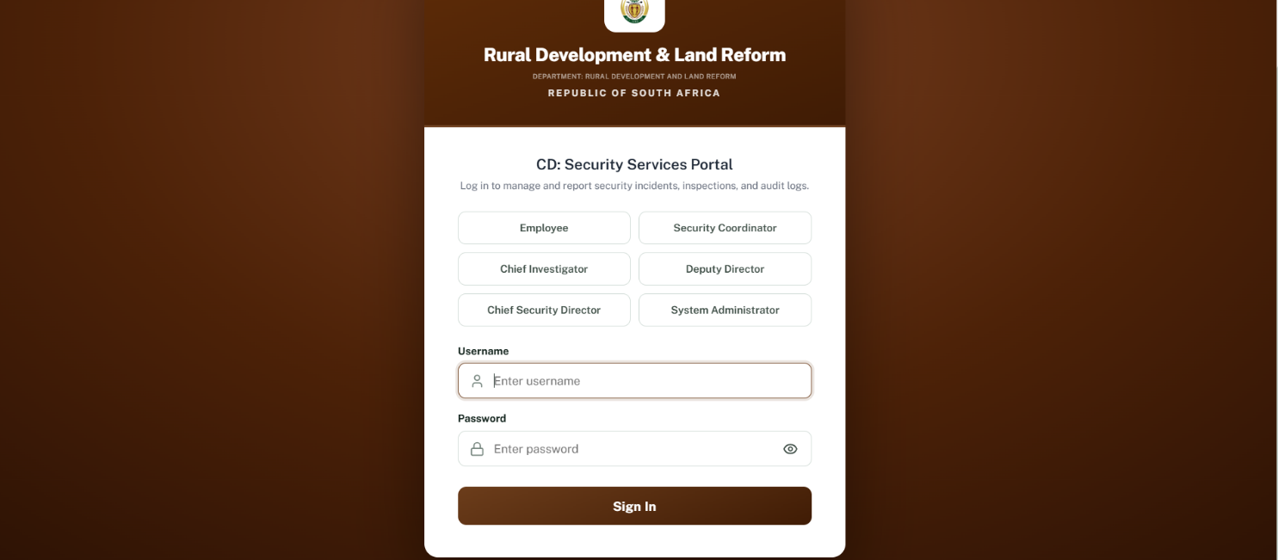

TEST CASES
Test Case CI-002

Dashboard

Field | Details
Test Case ID | CI-002
Module | Dashboard
Feature | Dashboard Overview & Navigation
Requirement | Verify that dashboard widgets and navigation components function correctly for the Chief Security Investigator role.
Preconditions | User is logged in as a Chief Security Investigator.
Test Data | Valid Chief Security Investigator account
Steps | 1. Log into the system.  2. Navigate to the Dashboard.  3. Verify dashboard statistics are displayed.  4. Click the Notifications icon.  5. Click the System Settings tile.  6. Review the dashboard for a recent incidents summary.
Expected Result | • Dashboard loads successfully.  • Dashboard statistics are displayed correctly.  • Notifications open successfully.  • System Settings opens the relevant page.  • Dashboard displays recent incidents for quick monitoring.
Actual Result | • Dashboard loads successfully.  • Dashboard statistics display correctly.  • Notifications function as expected.  • System Settings is not clickable and no action occurs.  • No recent incidents are displayed on the dashboard.
Status Pass | Fail
Comments | - Dashboard functionality is generally working as expected. However, the System Settings tile is non-functional despite appearing available, and the dashboard lacks a recent incidents summary.
Recommendations | • Enable navigation for the System Settings tile or remove/disable it until implemented.  • Add a Recent Incidents section (e.g., incidents from the past 30 days) to provide users with immediate visibility of active and recently reported cases, consistent with other system dashboards.
Screenshot | Yes.

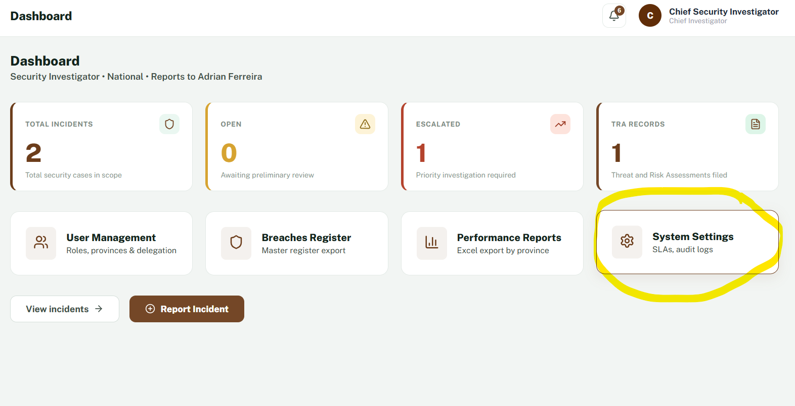

TEST CASES
Test Case CI-003

SUBMIT REPORT

Field | Details
Test Case ID | CI-003
Module | Report Incident
Feature | Incident Submission Form
Requirement | The Report Incident screen shall align with the approved Security Investigator User Journey and use consistent terminology and field layout.
Preconditions | User is logged in as Chief Security Investigator and has navigated to the incident reporting screen.
Test Data | Valid incident details.
Steps | 1. Log into the system.  2. Select the incident reporting option from the navigation menu.  3. Compare the page against the approved User Journey.  4. Complete and submit the incident.
Expected Result | - The system should align with the approved User Journey by displaying "Report Incident" consistently.  - The User Journey also indicates separate Date of Occurrence and Time of Occurrence fields.  - Upon successful submission, the system should generate a unique incident reference number and confirmation screen
Actual Result | - The navigation currently displays "Submit Reports" instead of "Report Incident" as shown in the approved User Journey.  - The Date and Time of Occurrence is presented as a single combined field rather than separate fields indicated in the User Journey.  - The incident submission process functions correctly, and a unique incident reference number is successfully generated with a confirmation screen.
Status Pass | Fail
Comments | - The incident submission functionality works as expected; however, the interface does not fully align with the approved User Journey due to inconsistent terminology and the combined date/time field.
Recommendations | - Update the navigation and page terminology to "Report Incident" throughout the module to match the approved User Journey.  - Modify the incident form to provide separate  - Date of Occurrence and Time of Occurrence fields as specified in the approved design.
Screenshot | Yes.
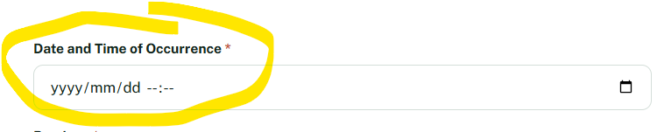

TEST CASES
Test Case CI-004

My Assigned Cases

Field | Details
Test Case ID | CI-004
Module | My Assigned Cases
Feature | View Case Details
Requirement | The system shall allow the investigator to open an assigned case for review and investigation as defined in the approved User Journey.
Preconditions | User is on the My Assigned Cases page.
Test Data | Existing assigned case.
Steps | 1. Navigate to My Assigned Cases.  2. Select the eye (View) icon for an assigned case.
Expected Result | - The selected case opens successfully, allowing the investigator to review case details and continue the investigation workflow.
Actual Result | - The selected case opened successfully and displayed the incident details for investigation.
Status Pass | Pass
Comments | - While the required date information is available, its placement under Case Details reduces readability and makes SLA monitoring less intuitive for investigators managing multiple cases.
Recommendations | - Add a dedicated Dates column to display Date Reported, Due Date, and Days Remaining/Overdue separately.  - This aligns better with the Security Investigator User Journey and improves case tracking.
Screenshot | Yes.
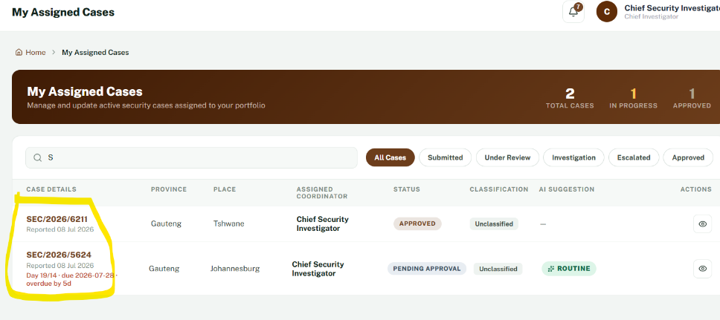

TEST CASES
Test Case CI-005

TRA Checklist
Field | Details
Test Case ID | CI-005
Module | Threat & Risk Assessment (TRA) Checklist
Feature | TRA Assessment Form, Checklist Completion & Digital Signature
Requirement | - Verify that the Chief Security Investigator can complete the Threat & Risk Assessment checklist, apply a digital signature, and submit the assessment successfully.
Preconditions | - User is logged in as Chief Security Investigator with access to the TRA Checklist module.
Test Data | - Assessment details, checklist responses (Yes/No/N/A), comments, and digital signature.
Steps | Navigate to the TRA Checklist module.  - Complete the Assessment Details section.  - Complete all checklist items by selecting Yes, No, or N/A and add comments where required.  - Proceed to the Assessor Signature section.  - Attempt to apply the digital signature.  - Submit the completed assessment.
Expected Result | - The assessment details are captured successfully, all checklist items can be completed, the assessor can digitally sign the assessment, and the completed TRA is submitted successfully.  - The Manager Signature section should remain locked until submission and approval.
Actual Result | - The TRA Checklist functions correctly. Assessment details, checklist responses, and comments can be completed successfully.  - Submission works as expected.  - The Manager Signature section is correctly locked pending approval.  - The digital signature security feature could not be fully tested because the required email access for signature verification was not available.
Status Pass | Pass (with Limitation)
Comments | - All tested functionality performed as expected.  - The only limitation was the inability to validate the digital signature authentication due to unavailable email access.
Recommendations | - Provide email access or the required authentication mechanism to complete end-to-end testing of the digital signature security feature, including signature verification and email notifications.
Screenshot | Yes.
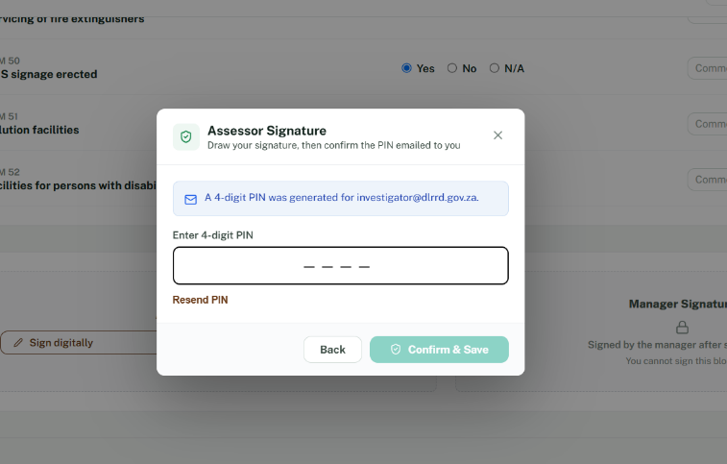

Field  Back to Office  TEST CASES  Test Case CI-006 | Details
Test Case ID | CI-006
Module | Back to Office Report
Feature | Back to Office Report Submission
Requirement | Verify that the Chief Security Investigator can complete and submit a Back to Office Report.
Preconditions | User is logged in as Chief Security Investigator with access to the Back to Office module.
Test Data | Official name, meeting details, venue, date, time, stakeholders, discussion points, matters for noting, signature, and designation.
Steps | 1. Navigate to Back to Office.  2. Complete all mandatory report fields.  3. Enter signature details and designation.  4. Submit the report.
Expected Result | - The user should be able to complete all required fields and successfully submit the Back to Office Report.  - The report should be saved and available in the filing history.
Actual Result | - The Back to Office Report form loaded successfully. All fields were accessible and functioned correctly.  - The report was completed and submitted successfully without any errors.
Status Pass | Pass.
Comments | - The module functions as expected.  - The report submission functions correctly; however, the Date and Times fields rely on manual text entry, increasing the risk of inconsistent formatting and user error.
Recommendations | - Replace the Date field with a calendar date picker and replace the Times field with dedicated Start Time and End Time picker controls to improve usability, consistency, and data validation.
Screenshot | Yes.

TEST CASES
Test Case CI-007

Field | Details
Test Case ID | CI-007
Module | Back to Office Report
Feature | Signature & Date Input Controls
Requirement | Verify that the Signature, Date, and Time fields provide appropriate input controls for accurate data entry.
Preconditions | User is logged in as Chief Security Investigator and has access to the Back to Office Report module.
Test Data | Signature code, report date, and meeting times.
Steps | 1. Navigate to the Back to Office Report module.  2. Scroll to the Signature section.  3. Review the Signature, Date, and Times fields.  4. Attempt to enter values into each field.
Expected Result | - The Date field should provide a calendar date picker.  - The Times field should provide a start time and end time selector (Time From – Time To) using a time picker.  - Input controls should minimise manual typing and improve data accuracy.
Actual Result | - The Date is displayed as a plain text field without a calendar picker in the Signature section.  - The Times field is a single long text input, requiring manual entry rather than providing separate start and end time selectors.
Status Pass | Fail (UI Enhancement Required)
Comments | - The report submission functions correctly; however, the Date and Times fields rely on manual text entry, increasing the risk of inconsistent formatting and user error.
Recommendations | - Replace the Date field with a calendar date picker and replace the Times field with dedicated Start Time and End Time picker controls to improve usability, consistency, and data validation.  - Change Title.
Screenshot | Yes.
Back to Office

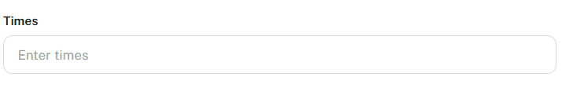

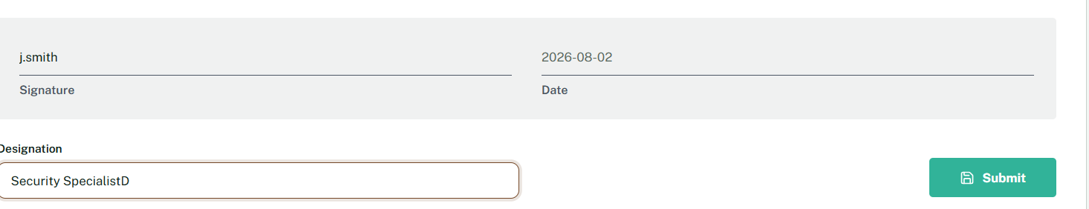

TEST CASES
Test Case CI-008

Breaches Register
Field | Details
Test Case ID | CI-008
Module | Breaches Register
Feature | Breaches Register Management
Requirement | Verify that the Chief Security Investigator can access and use the Breaches Register module successfully.
Preconditions | User is logged in as Chief Security Investigator with access to the Breaches Register module.
Test Data | Existing breach records.
Steps | 1. Navigate to the Breaches Register module.  2. Open the register.  3. Verify that breach records load correctly and available functions are accessible.
Expected Result | - The Breaches Register loads successfully, displays records correctly, and all available functions operate as expected.
Actual Result | 1.The Breaches Register loaded successfully.  - Records were displayed correctly, and all available functionality operated as expected without errors.
Status Pass | Pass
Comments | - The module performed as expected during testing. No functional or usability issues were identified.
Recommendations | None
Screenshot | No.

TEST CASES
Test Case CI-009

SLA Monitor
Field | Details
Test Case ID | CI-009
Module | SLA Monitor
Feature | SLA Monitoring and Deadline Tracking
Requirement | The system should provide investigators with clear visibility of all applicable Service Level Agreement (SLA) milestones, countdowns, deadlines, escalation statuses, and overdue cases throughout the incident lifecycle.
Preconditions | User is logged in as Chief Security Investigator and incidents exist with active SLA timelines.
Test Data | Active incident(s) with assigned SLA deadlines.
Steps | 1. Navigate to SLA Monitor from the left navigation menu.  2. Review the SLA information displayed.  3. Verify all available SLA notifications and deadline indicators.  4. Review overdue or expired incidents
Expected Result | - The SLA Monitor should display all relevant SLA stages for the assigned investigations, including countdown timers, investigation deadlines, escalation milestones, overdue indicators, task descriptions, and completion status to assist investigators in managing case timelines effectively
Actual Result | - The SLA Monitor displays a 12-hour SLA notification, 14-day Preliminary Investigation SLA, associated date and task, together with Overdue/Expired status indicators.  - The displayed information functions correctly; however, only limited SLA milestones are visible.  - Additional investigation lifecycle SLAs, countdown progress, escalation stages, and completion indicators are not displayed.
Status Pass | Fail
Comments | - The existing SLA notifications function correctly and accurately identify overdue or expired items. Navigation and display does not operate as expected.
Recommendations | - Expand the SLA Monitor to provide a more comprehensive view of the investigation lifecycle by including additional SLA milestones, countdown timers, escalation stages, completion progress, and status indicators where applicable.  - This would improve monitoring and case management for investigators.
Screenshot | Yes.
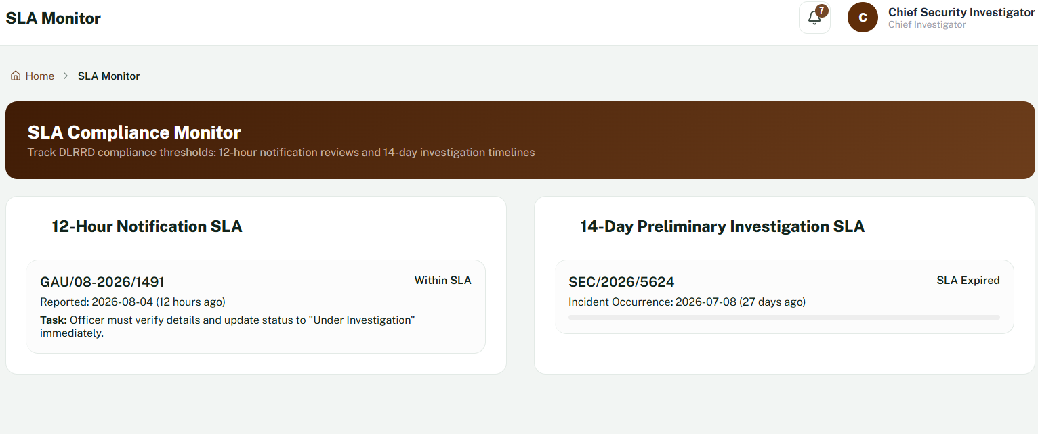

TEST CASES
Test Case CI-0010

Reports

Field | Details
Test Case ID | CI-0010
Module | Performance Reports
Feature | Monthly Statistics, Quarterly Reports & Filing Archive
Requirement | Verify that the Chief Security Investigator can access and view all Performance Reports sections, including Monthly Statistics, Quarterly Reports, and Filing Archive.
Preconditions | User is logged in as Chief Security Investigator with access to the Performance Reports module.
Test Data | Existing report data and archived records.
Steps | 1. Navigate to Performance Reports.  2. Open the Monthly Statistics section.  3. Open the Quarterly Reports section.  4. Open the Filing Archive section.  5. Verify that each section loads successfully and displays the available information.
Expected Result | - The Performance Reports module should load successfully.  - The Monthly Statistics, Quarterly Reports, and Filing Archive sections should be accessible and display the relevant report information without errors.
Actual Result | - The Performance Reports module loaded successfully. The Monthly Statistics, Quarterly Reports, and Filing Archive sections were accessible and functioned as expected.  - No navigation, display, or functionality issues were observed during testing.
Status Pass | Fail
Comments | - Most Performance Reports sections operated correctly and were accessible without any issues.  - The module supports reporting and historical record management for the Chief Security Investigator role.  - Does not allow the user to export the data.
Recommendations | - Drop down options for program/Branch.  - Export to Excel does not function.
Screenshot | Yes.
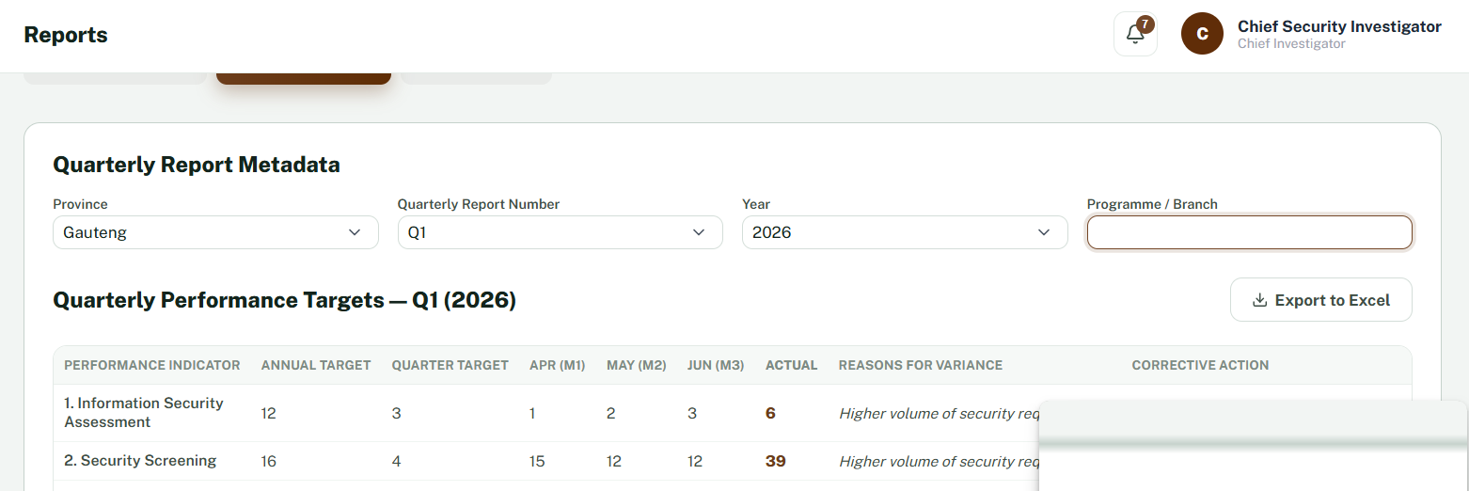

TEST CASES
Test Case CI-0011

AI Assistant

Field | Details
Test Case ID | CI-0011
Module | AI Assistant
Feature | AI Assistant Interaction
Requirement | Verify that the Chief Security Investigator can access and interact with the AI Assistant successfully.
Preconditions | User is logged in as Chief Security Investigator with access to the AI Assistant module.
Test Data | Sample user queries related to security incidents and investigations.
Steps | 1. Navigate to the AI Assistant module.  2. Enter a sample query.  3. Submit the query.  4. Review the AI Assistant response
Expected Result | 1.The AI Assistant should load successfully, accept user queries, process the request, and return an appropriate response without errors.
Actual Result | 1.The AI Assistant loaded successfully.  - User queries were accepted and processed correctly, and appropriate responses were returned.  - No functionality issues were observed during testing.
Status Pass | Pass
Comments | - The AI Assistant functioned as expected throughout testing.  - All tested features operated correctly.
Recommendations | No changes required.
Screenshot | No.

TEST CASES
Test Case CI-0012

Policy Hub (not explicitly mentioned)

Field | Details
Test Case ID | CI-0012
Module | Policy Hub
Feature | Policy Repository
Requirement | Verify that the Chief Security Investigator can access and view the latest approved security policies and procedures required to support investigations.
Preconditions | User is logged in as Chief Security Investigator with access to the Policy Hub.
Test Data | Approved security policies and procedures.
Steps | 1. Navigate to the Policy Hub.  2. Review the available policy sections.  3. Attempt to open or view the latest approved policy documents.  4. Verify whether documents can be accessed for reference during investigations.
Expected Result | - The Policy Hub should provide access to the latest approved security policies, procedures, and supporting documentation so investigators can reference them during investigations.
Actual Result | 1.The Policy Hub is accessible; however, there is no functionality that allows users to view or access the latest approved policy documents.  - No document repository or policy viewing functionality is available.
Status Pass | Fail.
Comments | - The module does not currently support access to approved policy documentation, limiting its usefulness as a reference tool for investigators.
Recommendations | - Implement a document repository within the Policy Hub that allows users to view the latest approved security policies and procedures.  - Include document titles, version numbers, effective dates, and revision dates to ensure investigators always reference current documentation.
Screenshot | No.

TEST CASES
Test Case CI-0013

Profile

Field | Details
Test Case ID | CI-0013
Module | My Profile
Feature | Edit Profile
Requirement | Verify that the Chief Security Investigator can edit and update their profile information.
Preconditions | User is logged in as Chief Security Investigator and has access to the My Profile module.
Test Data | Valid profile information.
Steps | 1. Navigate to My Profile.  2. Select Edit Profile.  3. Attempt to modify profile information.  4. Save the changes.
Expected Result | - The Edit Profile function should allow the user to modify permitted profile information and save the changes successfully.
Actual Result | - The Edit Profile function does not respond when selected, preventing the user from updating profile information.
Status Pass | Fail.
Comments | - The edit functionality is not operational, preventing profile updates.
Recommendations | - Investigate and implement the Edit Profile functionality to allow authorised users to update their profile information successfully.
Screenshot | Yes.

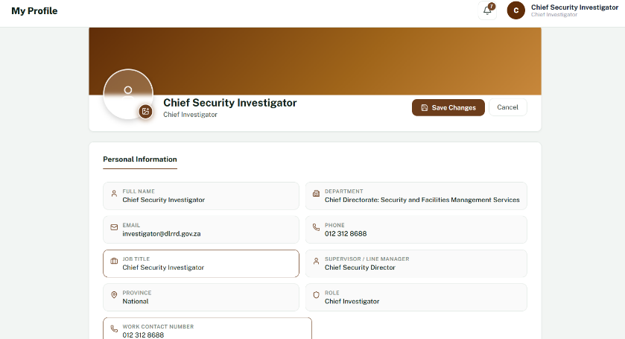

TEST CASES
Test Case CI-0014
Field | Details
Test Case ID | CI-0013
Module | Navigation Menu
Feature | Logout
Requirement | Verify that the Chief Security Investigator can successfully log out of the system.
Preconditions | User is logged in as Chief Security Investigator.
Test Data | Valid user session.
Steps | 1. Log into the system.  2. Locate the Logout option in the navigation menu.  3. Select Logout.
Expected Result | 1.The system should successfully terminate the user's session and redirect the user to the login page.  2.The Logout option should ideally be positioned at the bottom of the navigation menu as a separate account action.
Actual Result | 1.The Logout function operated successfully, terminated the user session, and redirected the user to the login page.  2.The Logout option is currently displayed within the main navigation menu rather than at the bottom.
Status Pass | Pass.
Comments | - Logout functionality performed as expected.  - The only observation relates to the placement of the Logout option within the navigation menu.
Recommendations | - Relocate the Logout option to the bottom of the navigation menu and visually separate it from the functional modules to improve usability and align with standard user interface design practices.
Screenshot | Yes.

Log Out

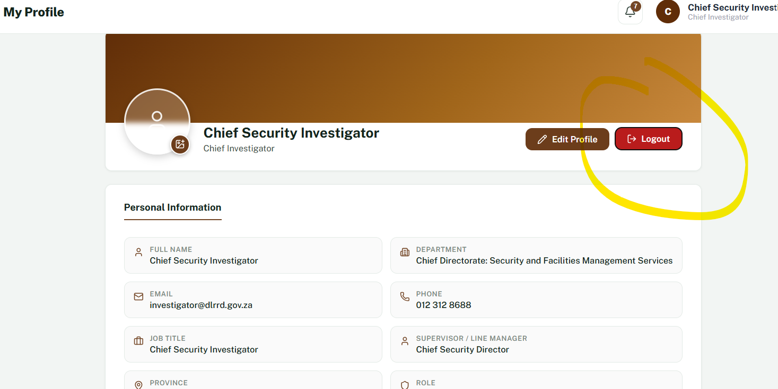

Observations
- Dashboard loaded successfully with no performance issues.
- Navigation menu functioned correctly throughout testing.
- Role-based access was correctly restricted to the Chief Security Investigator.
- Incident reporting functioned successfully and generated a unique reference number upon submission.
- My Assigned Cases displayed assigned investigations correctly, with search and status filtering functioning as expected.
- Threat & Risk Assessment (TRA) Checklist operated successfully; however, the digital signature security verification could not be fully tested due to unavailable email access.
- Back to Office Report was successfully completed and submitted without functional issues.
- Breaches Register loaded successfully and functioned as expected.
- SLA Monitor displayed active SLA notifications and overdue/expired tasks correctly but currently provides limited SLA visibility.
- Performance Reports (Monthly Statistics, Quarterly Reports, and Filing Archive) loaded successfully and functioned correctly.
- AI Assistant responded successfully to user queries and operated without errors.
- Logout functionality successfully terminated the session and redirected the user to the login page.
- Overall system navigation was stable, with no authorization or access control issues identified during testing.
Test Conclusion
Overall Result: PASS (With Defects)

Summary
- Number of test cases executed: 14
- Number passed: 7
- Number passed with recommendations/UI enhancements: 3
- Number failed: 7
- Number of defects identified: 5

Defects Found
Defect ID | Module | Description | Severity | Screenshot | Status
BUG-001 | Login | Login page layout does not align with the approved OHS login design. | Low | Yes | Open
BUG-002 | My Assigned Cases | Date information is displayed within the Case Details column instead of a dedicated Dates section, reducing readability for SLA tracking. | Low | Yes | Open
BUG-003 | Policy Hub | No functionality available to view or access the latest approved policy documents. | Medium | Yes | Open
BUG-004 | My Profile | Edit Profile functionality is not operational. | Medium | Yes | Open
BUG-005 | Back to Office Report | Date field does not provide a calendar picker, and Times field does not provide separate start and end time selectors. | Low | Yes | Open

